# [We're Simulating Civilisation (in Minecraft)](https://protostars.circle.so/c/07-project-directory/we-re-simulating-civilisation-in-minecraft)

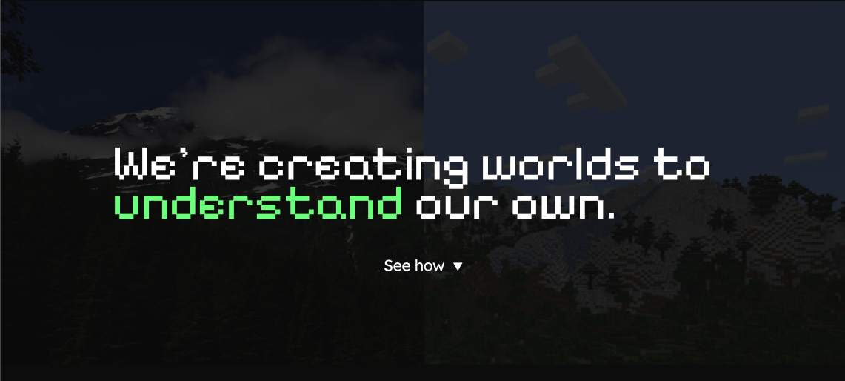

**📝 About Your Passion Project**

Wouldn’t Minecraft be so much cooler if you could join an army, build an empire, engage in politics, trade, espionage and more?

We’re running a series of Minecraft events to understand if our custom-developed modifications to the game will induce (in an emergent way) player interdependence, societal formation, commerce, war, politics and everything in-between.

We’ve demostrated that our custom server plugins, over a series of “trial” events, lead to these emergent behaviours. Our game design philosophy is quite simple: we want to change & add the the fewest number of mechanics that will organically/emergently result in these complex social dynamics. This is in contrast to developing the features directly: e.g. we haven’t implemented any sort of explicit team formation mechanics, but we have increased the difficulty of the game which results in the necessity of teamwork.

If any of this sounds interesting to you and you’d like to learn more or even play on the server yourself, you can join our Discord with over 5000 other curious players here: <https://discord.gg/JZ8BZa6hhR>. We’re working hard on developing a landing page :).

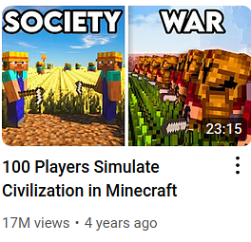

Have you ever seen a YouTube video with a thumbnail like this? “Minecraft Civilisation” videos are an exceptionally popular sub-genre of Minecraft YouTube videos. The premise is usually quite simple: what happens when you put 1000 real players into a single multiplayer minecraft world? Usually armies form, here’s politics, drama, betrayal, etc. All this is narrated and presented through the omniscient perspective of the YouTuber who participates as the storyteller. The story-lines are usually on-par or better than most TV shows I’ve seen, and what makes it better is that it’s all real (or is it…)!

The biggest YouTubers participating in this sub-genre are: <https://www.youtube.com/@ish> (Ish), <https://www.youtube.com/@MARCUSK298> (MARCUSK) and traditionally <https://www.youtube.com/@MagicGum> (MagicGum).

On July 4th 2025, YouTuber Joyfuul released a critique of these events titled: “The problem with simulating society in Minecraft”, in this critique he outlines a number of systematic issues with these events which makes them fall short of what they promise. In my opinion, the most significant of these critiques is that the majority of these videos are broadly scripted (or at least directed). The YouTuber running the event often instructs influential players to do certain things (e.g. behind the scenes, the YouTuber may instruct a group leader to invade another group for more interesting viewing content). The consequence of this is that we have an interesting and exciting video to watch, but with an inability to replicate what happened in these videos for ourselves as players.

In his video, Joyfuul puts forwards a few ideas for what he believes would lead to the correct emergent phenomena. Rather than just leaving it as theory, we decided to just make it! Hence the birth of CivLabs. The traction has been phenomenal so far, with the Discord having over 5000 members and over 350,000 messages to date (oct 6) after only ~3 months of running. Furthermore, for the past 3 months we’ve been running a series of actual events (which we call trials). Each trial consists of ~20 3-hour play-sessions spaced across a few weeks. I’m currently renting 3 dedicated servers to run these events and we’ve been averaging ~200-500 players over the duration spread across the different servers.

The community is insane (in the best way possible), our players have released YouTube videos on our server (both role-playing particular personas within our world and analysis/video-essay style videos documenting their experience). Players on our server have also written up entire research reports (essays) on their experiences, their ideas to improve the simulation and much more 🤯.

Sorry to bury a lead, but we started a Gofundme: <https://www.gofundme.com/manage/get-specialization-experiment-civlabs-capacity-to-1000> and raised over $1500 in less than 24 hours. (We actually raised $500 in less than 10 minutes which is so completely insanely wickedly nuts).

I exported the Discord logs and extracted 46 user-created videos about our server across 26 unique creators! Across all videos we have 341,454 total views. I’ve put together a playlist with all the user created videos if you’re curious: <https://www.youtube.com/playlist?list=PLdRWyIJAu_wvJWZHi-FF82JFtvLk0fOK6>

**What’s the point of all this?**   
For me, the point is to prove we can design a game with these emergent behaviours and to test what modifications lead to that. People like playing games, people want to play a game like this, hence we made it. Did you know: PUBG: Battlegrounds (hence Fortnite), DayZ and Dota all had their origins in mods to existing games. If we succeed in making something sustainable, maybe that’s where we’ll end up 🤞

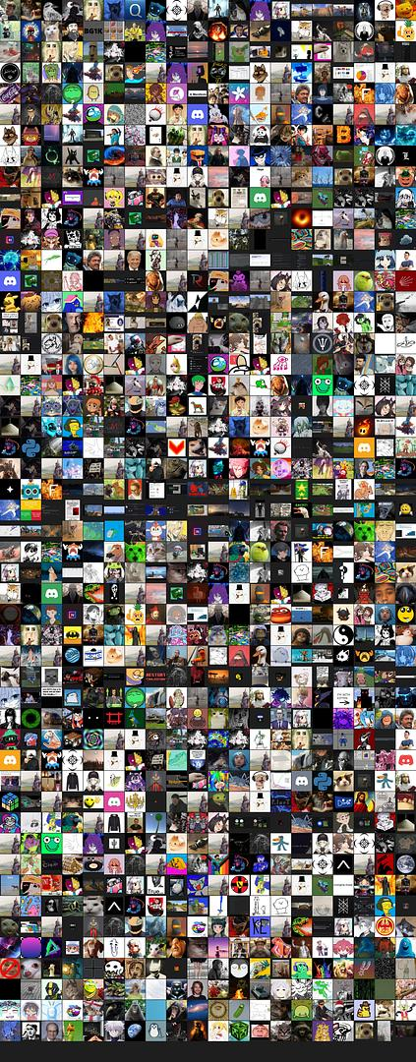



### **👥 Group Members / Collaborators**

**Our GoFundMe contributors who have made this entire thing possible:**

[**https://www.gofundme.com/manage/get-specialization-experiment-civlabs-capacity-to-1000**](https://www.gofundme.com/manage/get-specialization-experiment-civlabs-capacity-to-1000)

**The dedicated server staff:**

* Shotrush
* DNFneca
* Banana
* C0deJJ - 123
* Chargonium
* O2C
* Zayah
* Fyrine
* J
* Layl
* Miquel128

**The dedicated research staff:**

* Timmy71
* Sheetii
* Jono033

**The dedicated wiki moderation staff:**

* Dhabo
* thekaiserofgrancolombia_86032
* Soaral
* Markoviannuke (The Jester)
* Auguslan
* londonraptor
* nesworld

**Plus the Discord community moderation staff, all the research contributors, and most of all the event participants!**